Past winners (1982-2012)

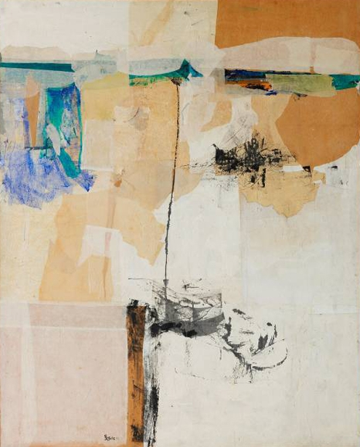

1982 UOB Painting Of the Year - Singapore

**The Dune**

Goh Beng Kwan, (b.1937, Indonesia)

Mixed Media and Collage on Wood Panel

157.5 x 128.5 cm

*The Dune* alludes to a special moment in the artist’s life when he was a student in the US under the mentorship of collage master Leo Manso. Mr Goh lived in Provincetown, Massachusetts – famous for its windswept sand dunes and beaches which have been captured in *The Dune*. The work also asserts its Asian identity through Chinese ink brush work.

Mr Goh, a Singapore Cultural Medallion recipient in 1989, was mentored by late pioneer artist Mr Chen Wen Hsi before his overseas art studies at the Art Students League, New York in 1962 and the Provincetown Workshop, Massachusetts in 1964. The Ford Foundation Scholarship was among the numerous accolades he received for his work. He was among a select group of artists returning from overseas studies who advocated abstraction and among the first to incorporate materials such as sand and rope into his collage paintings.

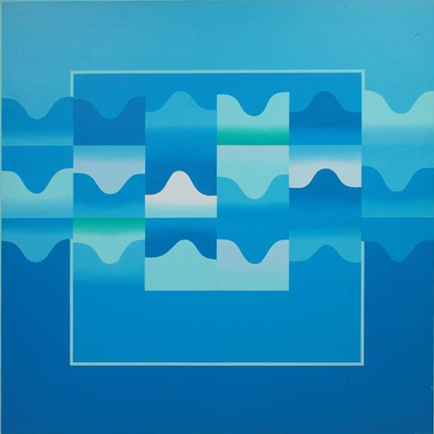

1983 UOB Painting Of the Year - Singapore

**Waves**

Anthony Poon, (b.1945 Singapore – 2006)

Acrylic on Canvas

193.5 x 193.5 cm

*Waves* is part of an innovative series for which the late Anthony Poon is best known. He was unquestionably Singapore’s leading proponent of Geometric Abstraction. His paintings, exemplified by *Waves*, typically carried colours and forms of extreme simplicity and featured paint application and finishing that was precise and immaculate.

Mr Poon was a graduate of the Nanyang Academy of Fine Arts in Singapore and the Bynam-Shaw School of Art in London. He was part of a group of artists who studied art overseas during the 1960s and then returned home advocating Abstract principles. By the 1990s he had become a central figure in corporate commissions for sculptures and paintings in public spaces. Mr Poon was conferred the prestigious Cultural Medallion in 1990, Singapore's highest award for those achieving artistic excellence.

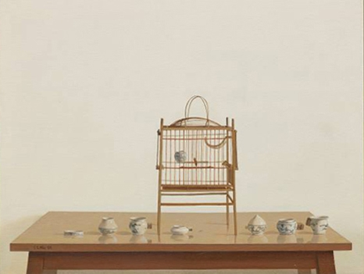

1984 UOB Painting Of the Year - Singapore

**Yuen (Affinity)**

Wee Shoo Leong, (b.1958, Singapore)

Oil on Canvas

86.2 x 109.0 cm

*Yuen* portrays delicate oriental porcelain water cups arranged with ritualistic care. They share table space with a simple wooden birdcage – its bird noticeably absent. Mr Wee’s still-life compositions typically involve local or Asian subjects and motifs in the photorealist style for which he is best known. A characteristic of Mr Wee’s work is a blank background which gives his paintings clarity and a sense of order and neatness. His restrained manner of painting and thoughtful detailing fill his works with a sense of quiet contemplation.

A graduate of the Nanyang Academy of Fine Arts, Singapore in 1979, Mr Wee later pursued painting at the Sydney College of the Arts, Australia. He was awarded the 1st Commonwealth Foundation Fellowship in 1986. He now paints full-time and his works are prized by art connoisseurs around the world.

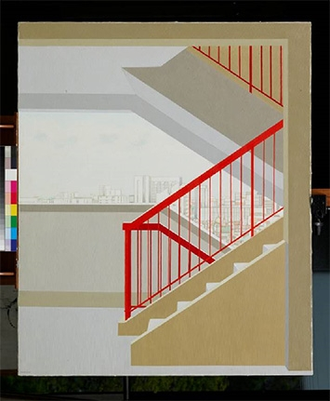

1985 UOB Painting Of the Year - Singapore

**Steps**

Ng Keng Seng, (b.1954, Singapore)

Acrylic on Canvas

132.0 x 112.5 cm

When *Steps* won the competition in 1985, the judges called it “a credit to Singapore art”. The simple, graphic treatment of the red railings in this painting belies the keen observation and detail in a typical public housing estate in the distance.

In his measured methodical painting style, Mr Ng draws our attention to things we neglect to notice – the ubiquitous staircase in a block of public flats. His handling of the bright railings provides visual accent, symmetry and rhythm to the composition.

A self-taught artist and illustrator, Mr Ng has produced works shaped by surrealist influences and has contributed illustrations to the local Chinese newspaper.

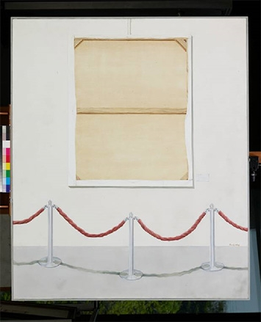

1986 UOB Painting Of the Year - Singapore

**Exhibit ‘86**

Sandy Wong Shin, (b.1963, Singapore)

Oil on Canvas

153.0 x 127.8 cm

With a clever twist on the topic of a prize-winning painting, Ms Wong depicts the celebrated work as a reversed canvas. The painting has its back turned to the viewer and is barricaded as if it were a precious museum possession. Ms Wong details the work scrupulously - observing the pinewood grain of the stretcher, the uneven flaps and edges of the canvas fabric, and the small staples all around. This draws our attention to textures and details that we rarely notice.

A graduate of the Nanyang Academy of Fine Arts, Singapore in 1983, Ms Wong has enjoyed recognition with awards that include the Silver Medal, Salon des Artistes Francais, Grand Palais Paris, France and the 1984 Tan Tsze Chor Art Award.

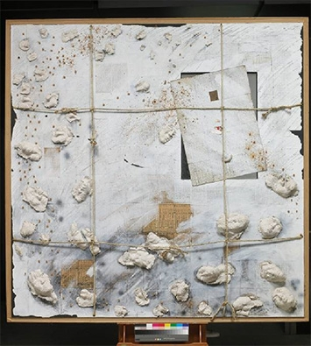

1987 UOB Painting Of the Year - Singapore

**Man And Environment I**

Baet Yeok Kuan, (b.1964, Singapore)

Mixed Media on Wood Panel

200.0 x 200.0 cm

Mr Baet expresses the relation and conflict between man the environment with the wu xong (or Five Elements) – water, fire, wood metal and earth - which are represented by various small objects in this tactile and robust collage.

The background features pages from a copy of a tong shu or almanac which used to be kept in every Chinese household. Some are actual pages whiles others are copies. Both are used by the artist to symbolise the principle of opposites in the yin and yang.

A grid motif recurs in the layout of the paper clippings and the knotted ropes – suggesting structure, containment and restraint. A more organic, unpredictable impulse is discernible through the human faces emerging from the painting, as if defying the constraints of their environment.

A graduate of the Nanyang Academy of Fine Arts in Singapore, Mr Baet later obtained his Master of Fine Art degree from the University of Central England, Birmingham in the United Kingdom. He was awarded the Young Artist Award by the National Arts Council, Singapore in 1995.

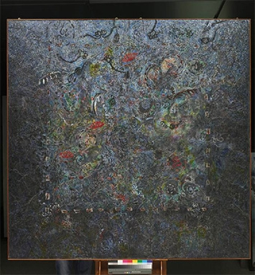

1988 UOB Painting Of the Year - Singapore

**One’s Habitat**

Ang Yian Sann, (b.1964, Singapore)

Mixed Media and Collage on Paper

198.0 x 195.0 cm

A dense, monumental work that vibrates with energy and motion, *One’s Habitat*explores the link between tangible dwellings and their spiritual or metaphysical dimensions. Mr Ang’s meticulous layering and rich detailing create a profound realm filled with sentient creatures and plant-life as well as mystical energies. These elements convey a sense of growth, movement and change, compelling the viewer to explore the habitat’s hidden depths.

Mr Ang obtained his Master in Industrial Design from the Royal Melbourne Institute of Technology, Australia under a Lee Foundation scholarship. A former lecturer in industrial art and critical design at the National University of Singapore, he now works in his studios in Singapore and Hue, Vietnam.

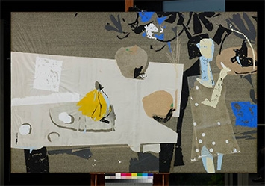

1989 UOB Painting Of the Year - Singapore

**From The Turtledove**

Lim Tiong Ghee, (b.1955, Singapore)

Collage on Wood Panel

125.0 x 189.0 cm

Mr Lim is known for his allegorical paintings in which the main protagonists are man and woman. The title of this particular collage, *From the Turtledove*, is borrowed from the ancient Chinese text, The Classics of Poetry. The collage reflects the feelings of expectant joy and apprehension of a young woman on the threshold of adult life. She is featured with a pair of turtle doves – the traditional symbol of devoted love and affection. Mr Lim uses colour sparingly and only as an accent, organising space and forms with intuition and sensitivity to achieve visual harmony.

Mr Lim is a self-taught artist whose works embody a poetic, lyrical quality typically featuring Asian motifs and references. He was a graphic artist at the former Singapore Broadcasting Corporation before pursuing art full-time. He has developed a reputation for his collage and mixed media works, winning several art prizes and accolades.

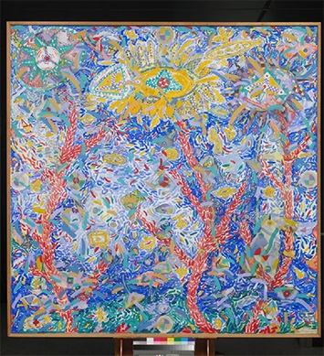

1990 UOB Painting Of the Year - Singapore

**City**

Lim Poh Teck, (b.1963, Singapore)

Acrylic and Collage on Canvas

181.0 x 181.0 cm

This work is an imaginative portrait of a *city* that is teeming with life and energy. Concerned with environmental issues and the alienation experienced by young people, Dr Lim depicts what he sees as the chaos of modern life in an intriguing variety of organic symbols. The artificial appears to have cross-fertilised with organic matter resulting in geometric shapes fused with vegetal forms. Dr Lim’s signature technique of applying colourful paint in tiny, meticulous strokes produces a sense of density and rhythm.

Dr Lim is a lecturer at the Nanyang Academy of Fine Arts in Singapore. He has a PhD in Arts Studies from Peking University and a Masters in Media Art from the University of New South Wales, College of Fine Arts in Australia. He was a recipient of the Australian Art Award Scholarship in 1986 and the Young Artist Award from the National Arts Council, Singapore in 1997.

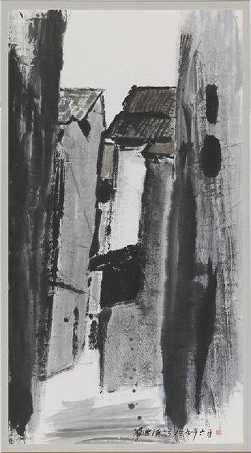

1991 UOB Painting Of the Year - Singapore

**My Haunt**

Chua Ek Kay, (b.1947 China - 2008)

Chinese Ink and Colour on Paper

199.5 x 113.7 cm

*My Haunt* stands out as a significant contemporary Chinese ink painting for its simplicity of form and decisiveness of brushwork. A combination of emphatic, powerful strokes and feathery, sensitive ones in a single dominant colour produce a spectrum of visual rhythms. The artist’s favourite haunts were the back-alleys of old Chinatown shophouses that he loved to paint. This interest evolved into the Street Scenes series for which he is well remembered.

The late Mr Chua was a 1999 Singapore Cultural Medallion recipient and his work is celebrated for re-energising the ink tradition. Mentored by the late Mr Fang Chang Tien in the xieyi expressive school, Mr Chua later pursued studies at Lasalle-SIA College of the Arts in Singapore, and the University of Tasmania and the University of Western Sydney, both in Australia. He integrated various philosophies of aesthetics into his work, sometimes including post-modern theories in his artistic practice.

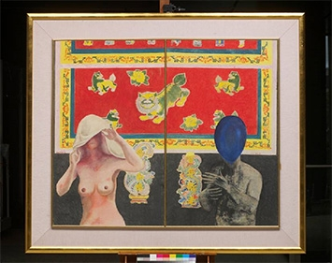

1992 UOB Painting Of the Year - Singapore

**Blue Balloon**

Soh Chee Hui, (b. 1967, Malaysia)

Mixed Media on Wood panel

147.7 x 171.0 cm

This curious visual narrative brims with cryptic implications and addresses coupling in its more complicated aspects. The juxtaposition of the traditional background and the contemporary rendering of the figures also underlines the dilemma faced by men and women in a modern society - how much of the past do we bring with us into the future?

The perfect pairing of the celestial phoenix and dragon, signifying yin (feminine) and yang (masculine), is believed to produce marital bliss and fertility. Here, the female is shrouded in white (rather than the customary red for celebration) and she is naked – suggesting vulnerability and exposure. A blue balloon conceals the man’s face and his naked body is depicted in murky colours. The overall image conveys a sense of the unknown or the unknowable in the ritual of coupling.

A graduate of Singapore’s Nanyang Academy of Fine Arts, Mr Soh pursued further art studies at the University of Central England, Birmingham, in the United Kingdom. He has forged a reputation for skilful painting that incorporates motifs and references to Asian culture and identity.

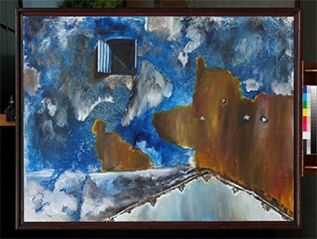

1993 UOB Painting Of the Year - Singapore

**Echoes of the Window (I)**

Raymond Lau Poo Seng, (b.1968, Singapore)

Acrylic on Canvas

114.5 x 148.0 cm

In art and literature, a window bears associations with freedom and opportunities. In*Echoes of the Window (I)*, it is not just the window that is the focus but also the distinctive blue wall with which it is partnered. Both are rendered in Mr Lau’s characteristic expressive style - brushwork that is energetic and unrestrained and the use of vibrant, emotive colours. His wall, punctuated by a single hopeful window, exudes character and history with its peeling paint and roughened and marked surfaces. The painting leaves itself open to opposing interpretations making the viewer wonder if he is looking in or out.

Old buildings are a favourite theme of Mr Lau who has said there is tranquillity in things that are old. He feels there is a need for the conservation of old buildings as it is only through the past that one can appreciate the present.

A graduate of the Lasalle-SIA College of the Arts in Singapore, Mr Lau obtained his Bachelor of Fine Arts at the University of Tasmania in Australia. Commended for his expressive style, Mr Lau has received art accolades and mentions including Singapore’s National Arts Council Young Artist Award.

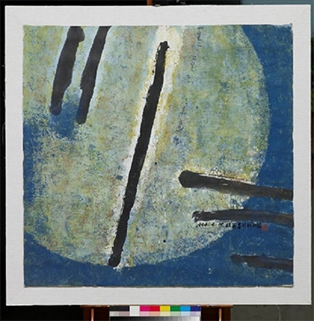

1994 UOB Painting Of the Year - Singapore

**Yi-Er-San (One, Two, Three)**

Hong Zhu An, (b.1955, China)

Chinese Ink and Colour on Paper

120.0 x 122.7 cm

Rich with textural nuances and pulsating with colour, *Yi-Er-San* evokes a mystical full moon night. The painting is a unique blend of Chinese calligraphy and Western abstract art. The Chinese characters *Yi-Er-San* or One-Two-Three written in bold calligraphic strokes across the work are an allusion to the birth and origins of the universe. Ancient Chinese numerology was related to cosmology with Yi representing the first creation of Heaven, Er signifying the genesis of Earth and San, the creation of Man.

A former lecturer at the Shanghai School of Arts and Crafts, Mr Hong pursued his graduate studies at Lasalle-SIA College of the Arts, Singapore and the Royal Melbourne Institute of Technology, Australia. One of Singapore’s eminent contemporary ink painters, Mr Hong is a noted colourist whose deeply layered works are commended for their lyrical, expressive qualities.

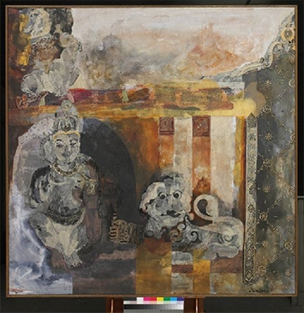

1995 UOB Painting Of the Year - Singapore

**The Statue Of Gods**

Tan Chin Chin, (b.1966, Singapore)

Mixed Media on Canvas

172.0 x 172.0 cm

Singapore’s multi-cultural and multi-religious roots are the central focus of this work featuring Indian gods and the Chinese chi-lin, a mythical creature with a lion’s head and horse’s body. Ms Tan creates an exotic, atmospheric work with a richness that is conveyed through warm colours and dynamic layering. Opaque colours alternate with translucent ones, with visual accents offered by the intricate patterns of ethnic lace.

A graduate of the Nanyang Academy of Fine Arts in Singapore, Ms Tan pursued her Masters in Fine Arts at the Parsons School of Design, New York in the United States. She is noted for her collage works that use ethnic or local fabrics, and her accolades include the 1994 Philip Morris ASEAN Art Award.

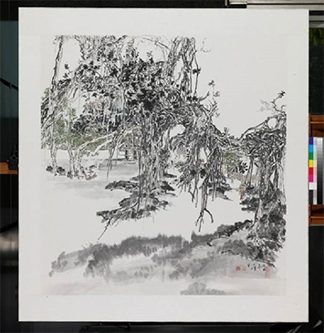

1996 UOB Painting Of the Year - Singapore

**Roots**

Chen Shi Jin, (b.1959, Singapore)

Chinese Ink and Colour on Paper

178.0 x 165.0 cm

*Roots* was described as a “symphony” by the 1996 judging panel as they could almost hear the thunderous sound of the trees and roots intersperse harmoniously with the bells in the distance of the piece. An unusual composition, *Roots* depicts an old banyan tree with its aerial roots reaching downward. The monumental scale of the tree is heightened by Mr Chen’s delicate detailing of the tiny human figures and pavilions, creating a seamless unity between man and nature.

Mr Chen is a graduate of the Nanyang Academy of Fine Arts, Singapore and the China Academy of Fine Arts, China. He has developed a reputation for his landscapes and paintings of rural communities and their rituals and festivals.

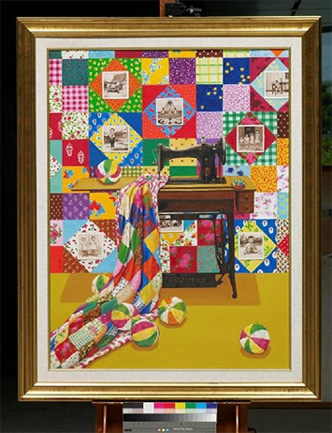

1997 UOB Painting Of the Year - Singapore

**Endless Love**

Kit Tan Juat Lee, (b.1955, Singapore)

Oil on Canvas

145.5 x 115.3 cm

*Endless Love* is a visual treasure-trove of the artist’s memories of her mother and exudes warmth and optimism. Ms Tan paints the emblems of her childhood - the manual Singer sewing machine with its Chinese-doll pin-cushion, the paper bola (Malay for ball) and her mother’s patchwork quilt. The vintage sepia photographs on the wall capture important childhood memories and milestones. These objects, largely phased out in contemporary life, embody security, and joyfulness. Ms Tan’s memories are far from faded and are recorded with precision and vividness. The painting dares the viewer to come closer to explore its colours and textures until finally the rewards present themselves in exquisite detail.

Ms Tan was a former educator in Chinese heritage and culture and a graduate of the Nanyang Academy of Fine Arts and Nanyang University, both in Singapore. Currently a professional artist, her interest in contemporary Asian identities has evolved alongside a signature style of immaculate painting, vivid colours and graphic sensibilities.

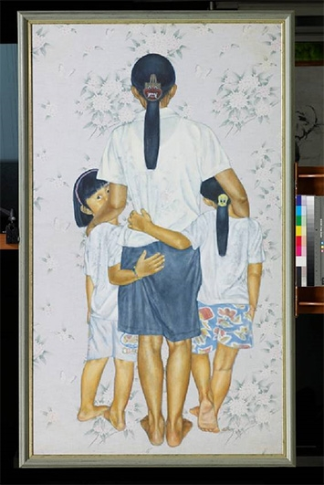

1998 UOB Painting Of the Year - Singapore

**She Loves Me But She’s Not My Mummy**

Chng Chin Kang, (b.1963, Singapore)

Acrylic on Linen

179.0 x 108.0 cm

In his distinctive realist style, Mr Chng asserts a social commentary on modern day families and their reliance on foreign maids. To symbolise how the maid is unknown to us, Mr Chng has painted her from the back. Yet we entrust her to the important task of parenting. In this painting, the maid protectively embraces the children and appears to usurp the biological mother’s role by going beyond care-giving and offering the children genuine affection.

The work is delicately executed on a floral wallpaper background which the subjects blend into, suggesting that the three are somehow neglected.

A graduate of the Nanyang Academy of Fine Arts, Mr Chng pursued advanced art studies at the University of Central England in the United Kingdom. His realist style, often paired with observations on contemporary city culture and society, has earned him accolades including the Philip Morris ASEAN Art Award and Vermont Studio Centre Freemen Fellowship in the United States.

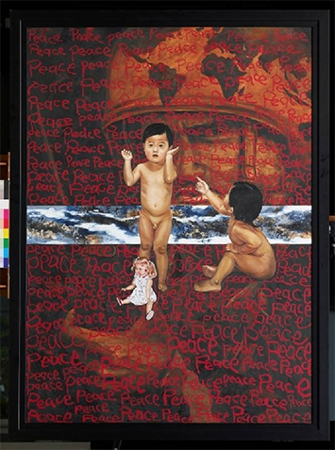

1999 UOB Painting Of the Year - Singapore

**Trifling Matter**

Tan Kay Nguan, (b.1965, Singapore)

Oil on Canvas

175.7 x 130.3 cm

Prompted by the reported violence in Kosovo and Indonesia, *Trifling Matter* delivers a visual ode to *peace* and an appeal for the end to violence. The word ‘peace’ is scribbled tirelessly across the canvas in naïve, childlike script, obscuring the lurking presence of the armed soldier. The two toddlers who take centre-stage embody the hope of a nation. The canvas appears to part in the middle, revealing what seems to be an extraordinary landscape - a utopian, paradisiacal realm.

A graduate of the Royal Melbourne Institute of Technology, Australia, Mr Tan also attained a Master of Art degree from the University of Central England, in the United Kingdom. He has won leading art prizes including the First Prize in the Tan Tsze Chor Art Award and the Japan Osaka Mayor Award. He has held numerous solo art exhibitions and his works are collected worldwide by art collectors and government bodies.

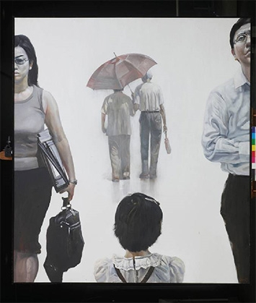

2000 UOB Painting Of the Year - Singapore

**They**

Fan Shao Hua, (b.1963, China)

Oil on Canvas

178.0 x 159.0 cm

*They* is a social commentary on the alienated contemporary family and a visual study of body language executed in Mr Fan’s signature realist style. A young child looks intently at a loving elderly couple, who are tenderly sharing an umbrella and walking into the distance. The child is sandwiched between a couple, likely her parents, who manifest psychological and emotional distance between themselves and their child. The unsmiling working mother carrying a briefcase is matched by an equally inhospitable scowling man whose folded arms indicate a defensive, aloof disposition.

Mr Fan is a graduate of the Academy of Fine Arts in Guangzhou and the Royal Melbourne Institute of Technology, Australia, and has a Ph.D. in Research of Fine Arts from the Nanyang Technological University in Singapore. He has won several notable accolades and is known for producing realist portraits as well as abstract paintings.

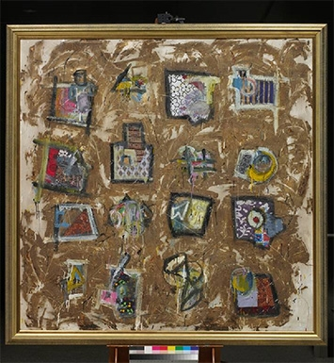

2001 UOB Painting Of the Year - Singapore

**It’s Hip 2 B Square**

Erzan B Adam, (b.1976, Singapore)

Mixed Media on Canvas

166.0 x 166.0 cm

This jaunty work comprises colourful local fabrics collected from the artist’s family and friends and bitumen, a sticky tar-like substance found in city roads. Full of energy and motion, this portrait of Singapore’s multicultural identity and heritage goes beyond the usual celebration of Singapore’s diversity. It offers depth and texture through the somewhat anarchic, chaotic movement created by the artist’s expressive brushwork.

Mr Erzan was 25 years old when he won the UOB Painting of the Year award. He pursued art studies at the University of Tasmania, Australia where he was placed on the Dean’s Roll of Excellence, and received his Master in Fine Art degree from Lasalle College of the Arts, Singapore in 2008. He is currently an artist, art educator and art project organiser.

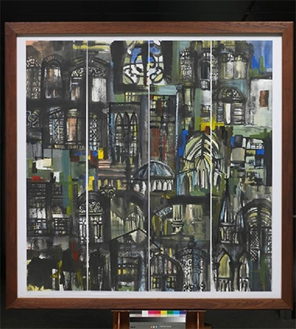

2002 UOB Painting Of the Year - Singapore

**The Impression Of Singapore Series - Three, Colour Space**

Gong Yao Min, (b.1964, China)

Chinese Ink and Colour on Paper

182.5 x 182.0 cm

Mr Gong’s impression of Singapore is that of a dense and compact city with pockets of sparkling light and space. His work synthesises the aesthetics of Western stained glass panels with their distinctive coloured illumination, and the versatility and fluidity of Chinese ink brushwork. The artist creates visual rhythms through alternating solid ink strokes with delicate patterning. Looking through his glass windows one can gaze at the city’s old colonial architecture. The painting is a re-energising take on the *shanshui*(mountain/water) tradition in Chinese ink painting.

Memorably saying that the prize money won from the UOB Painting of the Year competition bought him ‘time’, Mr Gong is now a professional artist. He is a graduate of the An Hui Educational University in China and Nanyang Academy of Fine Arts in Singapore.

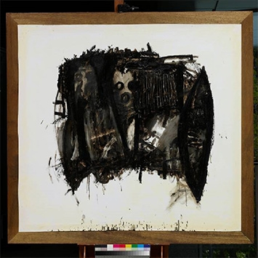

2003 UOB Painting Of the Year - Singapore

**Packed**

Luis Lee Jin Min, (b.1973, Singapore)

Mixed Media on Paper

154.0 x 164.0 cm

A highly expressive abstract painting, *Packed* emerged from Mr Lee’s interest in the urban packing box that is designed to compress and store possessions. The painting conveys the sensation of contents bulging from an imagined box, refusing to be orderly and contained. Mr Lee uses bitumen, a tar-like substance, as his paint and applies this in idiosyncratic and vigorous strokes. He allows the bitumen to splatter, stain and be scratched out. The effect is a work marked by raw, liberated energy that resists containment.

Mr Lee is a graduate of the Lasalle-SIA College of the Arts, Singapore and the Royal Melbourne Institute of Technology, Australia. He is currently a lecturer and practising artist.

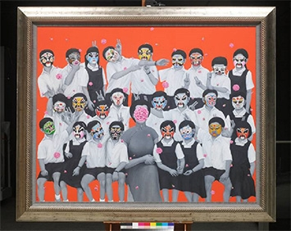

2004 UOB Painting Of the Year - Singapore

**The World Of Xi You Ji**

Kit Tan Juat Lee, (b.1955, Singapore)

Oil on Canvas

144.0 x 175.0 cm

This festive class portrait delivers an imaginative twist to a traditional story. It is inspired by the adventures of the Monkey God in the legendary*Xi You Ji* (Journey to the West), one of the four great classics of Chinese literature.

The teacher and students are depicted in the black and white of vintage photographs. It is the colourful masks that take centre stage. They animate their wearers who take on the mischievous behaviour of the Monkey God. The work suggests that classics such as *Xi You Ji* have a life of their own and will endure and outlive those who study them.

Ms Tan won her second UOB Painting of the Year Award with*The World Of Xi You Ji*. She is a former educator in Chinese heritage and culture and a graduate of the Nanyang Academy of Fine Arts, Singapore. Currently a professional artist, her interest in contemporary Asian identities has evolved alongside a signature style of immaculate painting, vivid colours and graphic sensibilities.

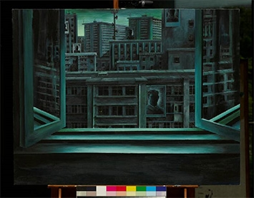

2005 UOB Painting Of the Year - Singapore

**The Window**

Alvin Ong Liang Jie, (b.1989, Singapore)

Acrylic on Canvas

109.0 x 122.0 cm

Shaped by surrealist influences and the dystopian vision of George Orwell, *The Window* is a visual articulation of the surveillance society. A window opens out to a cityscape bathed in a peculiar turquoise light. The colour accents the familiar forms of local public housing yet the scene remains curiously foreign in atmosphere. An air of paranoia and hyper-vigilance fills the air. The artist is cleverly ambivalent about the imaginary figure looking out of this window. We should not assume we are being surveyed because it is equally possible that we are playing the role of accomplice to Big Brother.

The youngest person to win the UOB Painting of the Year award at the age of 16, Mr Ong was regarded as something of an art prodigy with this painting. He is pursuing a Fine Arts degree at the University of Oxford in the United Kingdom and continues to practise painting.

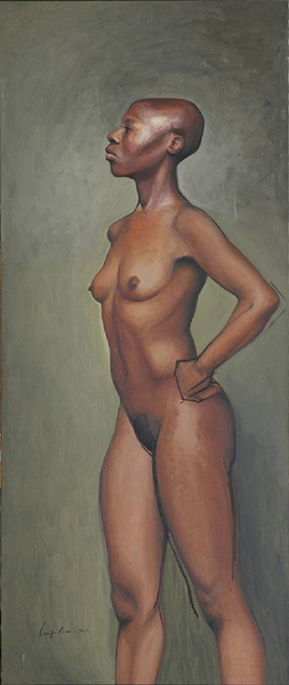

2006 UOB Painting Of the Year - Singapore

**Charisse**

Namiko Chan Takahashi, (b.1974, Singapore)

Oil on Linen

172.0 x 73.0 cm

*Charisse* is a striking portrait of the artist’s friend that clearly conveys its subject’s sense of self-possession. Exuding presence and bearing, this female nude embodies the ideals of beauty and empowerment. While most of the portrait is executed with impeccable finishing, the artist has retained rough sketch lines on the right arm and thigh. This imperfection or incompletion offers a more complex notion of beauty.

A law graduate of the National University of Singapore, Ms Takahashi has also pursued studies at the Art Students League of New York in the US, graduating in 2002. Currently a full-time artist, her repertoire has extended to painting, installations, performances and music and dance.

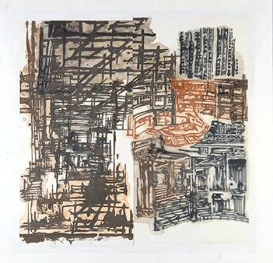

2007 UOB Painting Of the Year - Singapore

**Aspects Of The City II**

Hong Sek Chern, (b.1967, Singapore)

Ink on Paper

180.0 x 180.0 cm

Ms Hong splices fragments of the city to form a unique composite, extracting from the space beneath highways, public housing estates, playgrounds and walkways. Internal frames and interstitial spaces are mapped out from multiple viewpoints to form a matrix of the city. Everywhere we see glimpses of piping ducts, iron grids, concrete structures and beams. Melding principles and philosophies from Western art and Chinese ink traditions, Ms Hong reinvigorates the shanshui (mountain/water landscape) genre.

Ms Hong is a graduate of the National University of Singapore and the Nanyang School of Fine Arts, Singapore, and has a Master of Arts from Goldsmiths College, University of London, in the United Kingdom. She has won numerous awards including the Young Artist Award in 2000 and the President’s Young Talent Award in 2001, and has represented Singapore on the international stage at events such as the 2002 Sao Paolo Biennale. A former lecturer at the Nanyang Academy of Fine Arts, Ms Hong is currently a full-time professional artist.

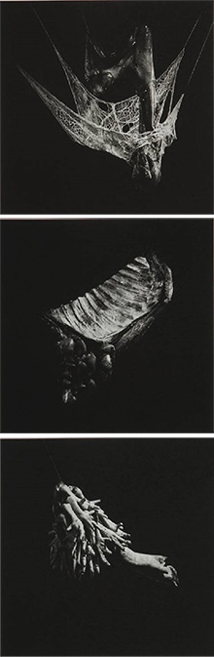

2008 UOB Painting Of the Year - Singapore

**Anatomical Fantasies Of Meat**

Joel Yuen, (b.1983, Singapore)

Archival Inkjet Print on Paper

115.0 x 117.0 cm

*Anatomical Fantasies Of Meat* is a response to man’s dominion over animals and a reminder of human ingenuity and bestiality. The artist explores beauty in the abject or reviled.

Mr Yuen’s control of light and shadow camouflages his subjects so that we are arrested by forms that are at once alien yet familiar. He in fact choreographs animal offal, flesh and innards to convey their viscosity, texture and muscularity in suggestive ways. What looks like a cobweb or insect sac turns out to be animal’s stomach. Plant-like branches turn out to be chicken feet shrewdly arranged to trigger multiple associations.

Mr Yuen is currently an adjunct lecturer at the Nanyang Technological University, School of Art, Design and Media in Singapore. He has a Masters in Fine Art from the Chelsea College of Art and Design in London. His works have been collected by the Singapore Art Museum.

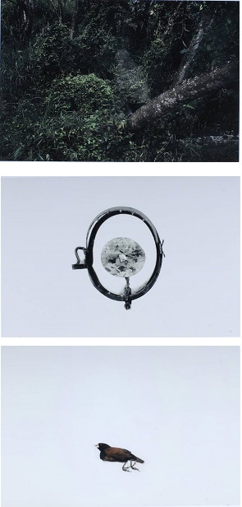

2009 UOB Painting Of the Year - Singapore

**The Space In Between**

Zhao Renhui, (b.1983, Singapore)

Archival Piezographic Print

90.0 x 130.0 cm

A lush dense forest scene, an animal trap and a fallen sparrow. These three distinctive images trigger the urge to decipher the perplexing visual riddle before us. The artist prompts us to question the truth of what we see. Closer scrutiny of the forest scene for instance reveals a figure concealed in a camouflage suit. The viewer is left to consider the grim implications of humankind’s study of nature and animal life. While Mr Zhao has interests in wildlife and nature conservation, the work extends beyond an activist’s crusade and is marked with ingenuity and a poetic quality.

Mr Zhao has a Master of Art degree in Photography from the London College of Communication. He is currently pursuing his art practice and continues to explore the theme of how humans watch and relate to animals in our society.

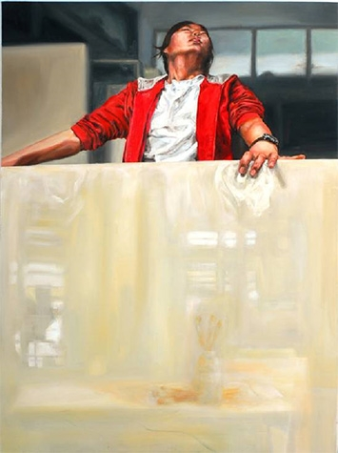

2010 UOB Painting Of the Year - Singapore

**What**

Bai Tianyuan, (b.1992, China)

Oil on Canvas

122.2 x 91.3 cm

Confronting and conquering the formidable empty canvas is a well-known experience for artists. This self-portrait of the artist gripping a canvas conveys a moment of struggle in the pursuit of the ultimate painting.

The striking scarlet-red of the artist’s jacket and rich flesh tones leap off the muted surroundings of the painting, suggesting that everything around her has receded in the urgency to find an answer. All feelings, tensions and aspirations are poured into the figure, but we are never quite sure if we are witnessing a moment of triumph or anguish.

A graduate of Raffles Institution in Singapore, Ms Bai is currently pursuing a degree in Fine Art at the School of the Art Institute of Chicago in the United States.

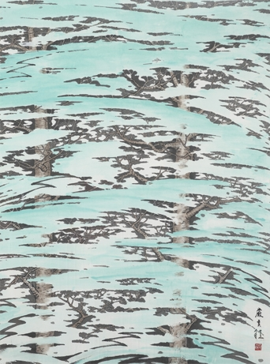

2010 UOB Painting Of the Year, Platinum Award - Singapore

**Splendour of Rainforests**

Ngiam Kiah Seng, (b.1950, Singapore)

Ink and Colour on Paper

123.5 X 93.5 cm

Mr Ngiam uses a yin-yang stroke technique to create the luxuriance and complexity of the rainforests and the effect of sunlight shining through the leaves.

To the artist, these majestic trees represent the success Singapore has achieved in education and as a financial centre. The seeds planted by the older generations have grown strongly over the years and developed into a sturdy rainforest that now provides shade and protection for generations to come.

Mr Ngiam is a graduate of the Nanyang Academy of Fine Arts in Singapore. He is a full-time artist whose works are collected by art connoisseurs around the world. His piece won the Platinum Award in the 2010 UOB Painting of the Year Competition. It is also the design inspiration behind the 2013 UOB Painting of the Year competition, as well as UOB’s 2012 Annual Report.

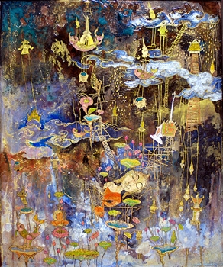

2010 UOB Painting Of the Year - Thailand

**Berg Fah Mai (Open New Sky)**

Pannaphan Yotmani, (b.1989, Thailand)

Mixed Medium

135.0 X 115.0 cm

In *Berg Fah Mai* Ms Yotmani tells a modern day story about the impact of global warming using traditional Thai folk iconography. Lotus leaves, statues of Buddha, temples and curling clouds float across the canvas in this alternate reality. She fuses the past and the present by combining drawing, lining and gold leaf pasting with modern materials such as resin.

The artist believes that the only way for humans to make up for the negative impact of global warming on the planet is to do good deeds. When an end comes to the old damaged world, only those who do good will be reincarnated into the new world.

Ms Yotmani is a graduate of Silpakorn University, Thailand where she is currently pursuing a Masters degree in Fine Art.

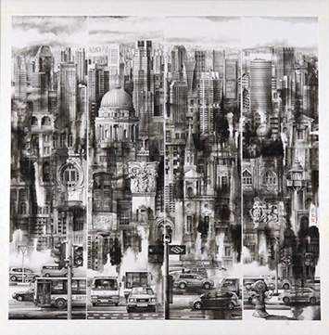

2011 UOB Painting Of the Year - Singapore

**My Dream Land**

Gong Yao Min, (b.1964, China)

Chinese Ink on Rice Paper

180.0 x 180.0 cm

Mr Gong brings his dream city into sharp focus in this painting which won him his second UOB Painting of the Year Award. The work is inspired by the artist’s impressions of Singapore. Having lived in the city for more than a decade, he wanted to capture its beauty and prosperity through its architecture. The artist reveals the city’s multiple facets in exquisite detail. Older iconic buildings that speak of Singapore’s rich culture and history meld with the modern skyscrapers of this Asian financial centre.

Memorably saying that the prize money won from the UOB Painting of the Year competition bought him ‘time’, Mr Gong is now a professional artist. He is a graduate of the An Hui Educational University in China and Nanyang Academy of Fine Arts in Singapore.

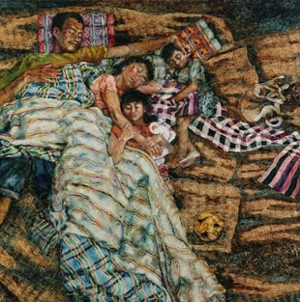

2011 UOB Painting Of the Year - Thailand

**Hug Of Love From My Family**

Suwannee Sarakana, (b.1979 Thailand)

Oil on Canvas

170.0 x 170.0 cm

The outsider looking in might think the family sleeping on these simple mats to be poor but they are rich in love. This intimate family portrait is inspired by Ms Suwanne’s own childhood in a small town in Northeast Thailand. Her parents were rice farmers who worked hard for a living, struggling in the dirt and heat of the sun. At night however, the day's exhaustion would evaporate in the love of her family as they slept together and this bond would strengthen them for the next day's work.

Ms Suwanne makes us question the importance of family in our own lives and the consequences of not treasuring our parents and siblings. Are we prepared for a day when we wake up from our modern beds to find our family gone?

Ms Suwannee is a renowned professional artist in Thailand.

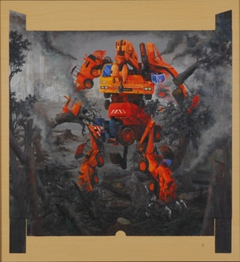

2011 UOB Painting Of the Year - Malaysia

**Portrayal of Development**

Ng Swee Keat, (b.1979, Malaysia)

Acrylic on paper cassette

87 x 81cm

*Portrayal of Development* is Mr Ng’s call for the preservation of the natural world. Modernisation has led to better living but has also resulted in the sacrifice of Mother Nature. Deforestation occurs at the whim of humanity with millions of hectares of forest and hundreds of animal species lost each year.

The focus of Mr Ng’s painting is a giant robot formed from construction vehicles that tears through a decimated and burning forest. Its cold steel takes on a fiery life of its own personifying the unrelenting path of destruction that humans have embarked on. The robot has no eyes, and like the humans who turn a blind eye to the damage being done to nature, it does not stop to see the consequences of its actions.

Mr Ng is a graduate of the Malaysia Institute of Art, where he majored in oil and Chinese ink painting. He is a full-time artist, whose works have been exhibited since 1999. His paintings have been collected by the National Art Gallery of Malaysia, art connoisseurs and international corporations.

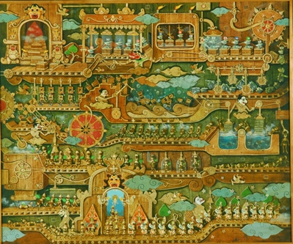

2011 UOB Painting Of the Year - Indonesia

**Repacking**

Gatot Indrajati, (b.1980, Indonesia)

Acrylic on Canvas

180.0 x 150.0 cm

Mr Gatot Indrajati makes a strong statement about the preservation of traditional art forms with *Repacking*. In his view, modernisation and globalisation should not be allowed to destroy traditional values and customs. The traditional Indonesian iconography moving along a modern conveyor belt in the painting is an invitation to repackage or reimagine traditional art in the modern era. The challenge is to do so without changing any of its substance or value.

While this is a two-dimensional painting, it takes on a collage-like appearance as Mr Gatot’s skilful brushwork creates three-dimensional shapes and breathes light into the piece.

Mr Gatot has participated in various national and international painting exhibitions. He was the winner of 2009 Indonesia Art Awards.

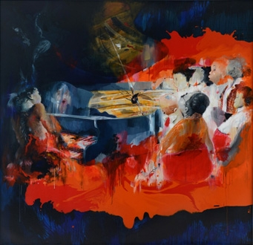

2012 UOB Painting Of the Year - Indonesia

**Himne Sekolah (School Hymns)**

Y. Indra Wahyu, (b.1977, Indonesia)

Acrylic on Canvas

175.0 x 180.0 cm

In these modern times, education, science and knowledge have become an absolute necessity for every human being. *Himne Sekolah* or *School Hymns* makes a strong statement about the importance of schools in fulfillingthis human need and advocates for greater care and attention to be paid to schools and the education system.

The painting depicts a pianist and a choir trying to create harmony in an environment that seems unorganised. With this work, Mr Y. Indra says he wants to encourage society to voice out openly the problems that exist in education and to work together to solve them. In his vision, different voices come together to create a single song of beauty that for him represents the ultimate destination for a nation.

Mr Y. Indra studied fine arts at the Institut Seni Indonesia, Yogyakarta. He continues to hold solo exhibitions and has won art awards in Indonesia.

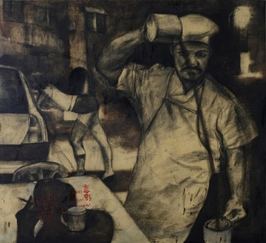

2012 UOB Painting Of the Year - Malaysia

**Ah Long**

Mohd Azri bin Abdullah, (b.1978, Malaysia)

Charcoal with bitumen

134.6 x 147.3cm

Mr Mohd Azri shines a light on the shadowy world of illegal money lending and the people who run it, known as *ah long* in Malaysia. The illegal money lending trade used to be covert and conducted by word-of-mouth, but now *ah long*s no longer operate “under the table”. In the artist’s opinion, they have surfaced their operations such that their presence can be felt almost everywhere. Their posters and “promotional materials” are all over the place including scribbled on tables in public places.

The back alleys of the urban, modern city of Kuala Lumpur are usually where the *ah long*s conduct their business. The depiction of the *ah long* as a shadow is both a literal and figurative reflection. Once the borrower is in the ah long’s books, there is no escaping his clutches – he will be a constant shadow dogging the borrower’s every moment.

Mr Mohd Azri graduated with a Diploma in Fine Art from the Malaysia Institute of Art. He paints part-time and has participated in several local art exhibitions. Following his win in the 2012 UOB Malaysia Painting of the Year competition, he has caught the eye of several art galleries and is currently working towards becoming a full-time artist.

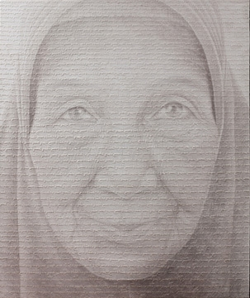

2012 UOB Painting Of the Year - Thailand

**Faith**

Aimrom Yunu, (b.1984 Thailand)

Acrylic On Canvas

161.0 x 136.0 cm

Mr Yunu touches hearts with a magnificent portrait of his beloved grandmother which expresses the strong religious values and belief in goodness that she imparted to him as a child.

To the artist, the world today is materialistic - full of competition, struggles and a desire for power and fortune. He feels that it is through religion that people learn to be good, decent and refrain from doing injustice to others. A Muslim who prays five times a day, Mr Yunu wrote his prayer repeatedly onto his painting with each prayer session to remind himself to do good deeds. “By praying five times each day, we gain an audience with God in a calm and self-controlled manner,” he says. This allows the mind to be cleansed, serene and content with a clear conscience in life.

Mr Yunu is pursuing a Masters degree in Fine Art at Silpakorn University, Thailand.

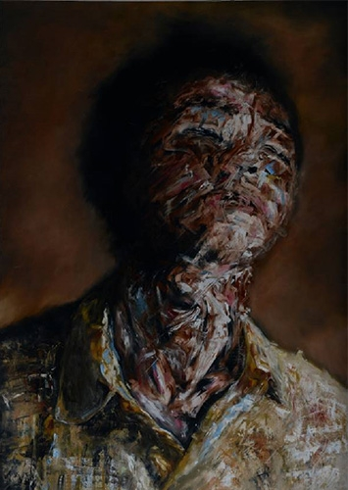

2012 UOB Painting Of the Year - Singapore

**Just Let Me Sleep**

Esmond Loh Fah Rong, (b.1995, Singapore)

Oil & Acrylic On Canvas

170.0 X 120.0 cm

*Just Let Me Sleep* is a self-portrait created at a time when the artist’s life was plagued by exhaustion and a loss of direction. The gestured nature of the strokes used to compose the face aims to bring out the chaos of the mind.

With no preconceived image of his painting, Mr Loh adopted an experimental approach, painting with creative impulse. The technique used was developed on its own during the process. The free exploration was a form of liberation for the artist.

Mr Loh has been interested in art from a young age but only became serious about his craft when he joined the art programme at St. Joseph's Institution. He is currently a student at Hwa Chong Junior College. His winning work was his first attempt at oil painting.